INDEX

TITLES PAGE NO
CONTENTS
ABSTRACT vi
- INTRODUCTION 1
- LITERATURE SURVEY 5
2.1 KEY-DEDUPLICATION WITH IBBE 5
2.2 SERVER LESS DISTRIBUTEDFILESYSTEM 6
2.3 THE GOOGLEFILESYSTEM 7
2.4 CONVERGENTKEYMANAGEMENT 8
2.5 SOFTWAREENVIRONMENT 9
2.6 WHY CHOOSEPYTHON 10
- SYSTEM ANALYSIS 14
3.1 EXISTING SYSTEM 16
3.2 PROPOSEDSYSTEM 16
- FEASIBILITYSTUDY 17
4.1 ECONOMICALFEASIBILITY 17
4.2 TECHNICALFEASIBILITY 17
4.3 SOCIALFEASIBILITY 18
- SYSTEMREQUIREMENTS 19

SYSTEMDESIGN 20
6.1 SYSTEMARCHITECTURE 20
6.2 DATAFLOW DIAGRAM 20
6.3 UMLDIAGRAMS 22

IMPLEMENTATION 27
7.1 MODULES 27
7.2 SAMPLE CODE 28

SYSTEMTESTING 29
8.1 UNITTESTING 31
8.2 INTEGRATION TESTING 32
8.3 ACCEPTANCETESTING 33

INPUT DESIGN ANDOUTPUTDESIGN 34
9.1 INPUTDESIGN 34
9.2 OUTPUTDESIGN 35

SCREENSHOTS 37

FUTUREWORK 50

CONCLUSION 51

BIBLOGRAPHY 52

ABSTRACT:
A new fingerprint compression algorithm based on sparse representation is introduced. Obtaining an overcomplete dictionary from a set of fingerprint patches allows us to represent them as a sparse linear combination of dictionary atoms. In the algorithm, we first construct a dictionary for predefined fingerprint image patches. For a new given fingerprint images, represent its patches according to the dictionary by computing l ⁰ -minimization and then quantize and encode the representation. In this paper, we consider the effect of various factors on compression results. Three groups of fingerprint images are tested. The experiments demonstrate that our algorithm is efficient compared with several competing compression techniques (JPEG, JPEG 2000, and WSQ), especially at high compression ratios. The experiments also illustrate that the proposed algorithm is robust to extract minutiae.

1. INTRODUCTION

Recognition of persons by means of biometric characteristics is an important technology in the society, because biometric identifiers can’t be shared and they intrinsically represent the individual’s bodily identity. Among many biometric recognition technologies, fingerprint recognition is very popular for personal identification due to the uniqueness, universality, collectability and invariance [1]. Large volumes of fingerprint are collected and stored every day in a wide range of applications, including forensics and access control. In 1995, the size of the FBI fingerprint card archive contained over 200 million items and archive size was increasing at the rate of 30 000 to 50 000 new cards per day [1]. Large volume of data consume the amount of memory. Fingerprint image compression is a key technique to solve the problem. Generally, compression technologies can be classed into lossless and lossy. Lossless compression allows the exact original images to be reconstructed from the compressed data. Lossless compression technologies are used in cases where it is important that the original and the decompressed data are identical. Avoiding distortion limits their compression efficiency. When used in image compression where slight distortion is acceptable, lossless compression technologies are often employed in the output coefficients of lossy compression. Lossy compression technologies usually transform an image into another domain, quantize and encode its coefficients. During the last three decades, transform-based image compression technologies have been extensively researched and some standards have appeared. Two most common options of transformation are the Discrete Cosine Transform (DCT) [2] and the Discrete Wavelet Transform (DWT) [3]. The DCT-based encoder can be thought of as compression of a stream of 8 × 8 small block of images. This transform has been adopted in JPEG [4]. The JPEG compression scheme has many advantages such as simplicity, universality and availability. However, it has a bad performance at low bit-rates mainly because of the underlying block-based DCT scheme. For this reason, as early as 1995, the JPEG-committee began to develop a new wavelet-based compression standard for still images, namely JPEG 2000 [5], [6]. The DWT-based algorithms include three steps: a DWT computation of the normalized image, quantization of the DWT coefficients and lossless coding of the quantized coefficients. The detail can be found in [7] and [8]. Compared with JPEG, JPEG 2000 provides many features that support scalable and interactive access to large-sized image. It also allows extraction of different resolutions, pixel fidelities, regions of interest, components and etc. There are several other DWT-based algorithms, such as Set Partitioning in Hierarchical Trees (SPIHT) Algorithm [9]. The above algorithms are for general image compression. Targeted at fingerprint images, there are special compression algorithms. The most common is Wavelet Scalar Quantization (WSQ). It became the FBI standard for the compression of 500 dpi fingerprint images [7]. Inspired by the WSQ algorithm, a few wavelet packet based fingerprint compression schemes have been developed. In addition to WSQ, there are other algorithms for fingerprint compression, such as Contourlet Transform (CT) [10]. These algorithms have a common shortcoming, namely, without the ability of learning. The fingerprint images can’t be compressed well now. They will not be compressed well later. In this paper, a novel approach based on sparse representation is given. The proposed method has the ability by updating thedictionary. The detail can be found in Section IV and V. The specific process is as follows: construct a base matrix whose columns represent features of the fingerprint images, referring the matrix dictionary whose columns are called atoms; for a given whole fingerprint, divide it into small blocks called patches whose number of pixels are equal to the dimension of the atoms; use the method of sparse representation to obtain the coefficients; then, quantize the coefficients; last, encode the coefficients and other related information using lossless coding methods. In most instances, the evaluation of compression performance of the algorithms is restricted to Peak Signal to Noise Ratio (PSNR) computation. The effects on actual fingerprint matching or recognition are not investigated. In this paper, we will take it into consideration. In most Automatic Fingerprint identification System (AFIS), the main feature used to match two fingerprint images are minutiae (ridges endings and bifurcations). Therefore, the difference of the minutiae between pre- and post-compression is considered in the paper. This paper is arranged as follows: section II summarizes the related works and gives some thoughts on the sparse representation; the model of the sparse representation and the algorithms for the model are set up in section III; the details of fingerprint compression based on sparse representation is given in section IV; experiments will be given in section V; in the end, we draw a brief conclusion and the future work.

2. LITERATURE SURVEY

2.1 A new, fast, and efficient image codec based on set partitioning in hierarchical trees

Authors: A. Said and W. A. Pearlman Abstract: Embedded zerotree wavelet (EZW) coding, introduced by Shapiro (see IEEE Trans. Signal Processing, vol.41, no.12, p.3445, 1993), is a very effective and computationally simple technique for image compression. We offer an alternative explanation of the principles of its operation, so that the reasons for its excellent performance can be better understood. These principles are partial ordering by magnitude with a set partitioning sorting algorithm, ordered bit plane transmission, and exploitation of self-similarity across different scales of an image wavelet transform. Moreover, we present a new and different implementation based on set partitioning in hierarchical trees (SPIHT), which provides even better performance than our previously reported extension of EZW that surpassed the performance of the original EZW. The image coding results, calculated from actual file sizes and images reconstructed by the decoding algorithm, are either comparable to or surpass previous results obtained through much more sophisticated and computationally complex methods. In addition, the new coding and decoding procedures are extremely fast, and they can be made even faster, with only small loss in performance, by omitting entropy coding of the bit stream by the arithmetic code.

2.2 Fingerprint compression using contourlet transform with modified SPIHT algorithm

Authors: R. Sudhakar, R. Karthiga, and S. Jayaraman, Abstract: Large volumes of fingerprints are collected and stored every day in a wide range of applications, including forensics, access control etc., and is evident from the database of Federal Bureau of Investigation (FBI) which contains more than 70 million finger prints. Wavelet based Algorithms for image compression are the most successful, which result in high compression ratios compared to other compression techniques. Even though wavelet bases are providing good compression ratios, they are not optimal for representing images consisting of different regions of smoothly varying grey-values, separated by smooth boundaries. This issue is addressed by the directional transforms, known as contourlets which have the property of preserving edges. This paper focuses mainly on the new fingerprint compression using contourlet transform (CT), which includes elaborated repositioning algorithm for the CT coefficients, and Modified set partitioning in hierarchical trees (SPIHT) which is applied to get better quality, i.e., high peak signal to noise ratio (PSNR). The results obtained are tabulated and compared with those of the wavelet based ones.

2.3 Robust face recognition via sparse representation
Authors: J. Wright, A. Y. Yang, A. Ganesh, S. S. Sastry, and Y. Ma Abstract: We consider the problem of automatically recognizing human faces from frontal views with varying expression and illumination, as well as occlusion and disguise. We cast the recognition problem as one of classifying among multiple linear regression models and argue that new theory from sparse signal representation offers the key to addressing this problem. Based on a sparse representation computed by C ¹ -minimization, we propose a general classification algorithm for (image-based) object recognition. This new framework provides new insights into two crucial issues in face recognition: feature extraction and robustness to occlusion. For feature extraction, we show that if sparsity in the recognition problem is properly harnessed, the choice of features is no longer critical. What is critical, however, is whether the number of features is sufficiently large and whether the sparse representation is correctly computed. Unconventional features such as downsampled images and random projections perform just as well as conventional features such as eigenfaces and Laplacianfaces, as long as the dimension of the feature space surpasses certain threshold, predicted by the theory of sparse representation. This framework can handle errors due to occlusion and corruption uniformly by exploiting the fact that these errors are often sparse with respect to the standard (pixel) basis. The theory of sparse representation helps predict how much occlusion the recognition algorithm can handle and how to choose the training images to maximize robustness to occlusion. We conduct extensive experiments on publicly available databases to verify the efficacy of the proposed algorithm and corroborate the above claims.
2.4 Image denoising via sparse and redundant representation over learned dictionaries
Authors: Abstract: e address the image denoising problem, where zero-mean white and homogeneous Gaussian additive noise is to be removed from a given image. The approach taken is based on sparse and redundant representations over trained dictionaries. Using the K-SVD algorithm, we obtain a dictionary that describes the image content effectively. Two training options are considered: using the corrupted image itself, or training on a corpus of high-quality image database. Since the K-SVD is limited in handling small image patches, we extend its deployment to arbitrary image sizes by defining a global image prior that forces sparsity over patches in every location in the image. We show how such Bayesian treatment leads to a simple and effective denoising algorithm. This leads to a state-of-the-art denoising performance, equivalent and sometimes surpassing recently published leading alternative denoising methods

2.5 SOFTWARE ENVIRONMENT
Python is a high-level, interpreted scripting language developed in the late 1980s by Guido van Rossum at the National Research Institute for Mathematics and Computer Science in the Netherlands. The initial version was published at the alt. Sources newsgroup in 1991, and version 1.0 was released in 1994.
Python 2.0 was released in 2000, and the 2.x versions were the prevalent releases until December 2008. At that time, the development team made the decision to release version 3.0, which contained a few relatively small but significant changes that were not backward compatible with the 2.x versions. Python 2 and 3 are very similar, and some features of Python 3 have been back ported to Python 2. But in general, they remain not quite compatible.
Both Python 2 and 3 have continued to be maintained and developed, with periodic release updates for both. As of this writing, the most recent versions available are 2.7.15 and 3.6.5. However, an official End of Life date of January 1, 2020 has been established for Python 2, after which time it will no longer be maintained. If you are a newcomer to Python, it is recommended that you focus on Python 3, as this tutorial will do.
Python is still maintained by a core development team at the Institute, and Guido is still in charge, having been given the title of BDFL (Benevolent Dictator For Life) by the Python community. The name Python, by the way, derives not from the snake, but from the British comedy troupe Monty Python’s Flying Circus, of which Guido was, and presumably still is, a fan. It is common to find references to Monty Python sketches and movies scattered throughout the Python documentation.

2.6 WHY CHOOSE PYTHON
If you’re going to write programs, there are literally dozens of commonly used languages to choose from. Why choose Python? Here are some of the features that make Python an appealing choice.

Python is Popular
Python has been growing in popularity over the last few years. The 2018 Stack Overflow Developer Survey ranked Python as the 7th most popular and the number one most wanted technology of the year. World-class software development countries around the globe use Python every single day.
According to research by Dice Python is also one of the hottest skills to have and the most popular programming language in the world based on the Popularity of Programming Language Index.
Due to the popularity and widespread use of Python as a programming language, Python developers are sought after and paid well. If you’d like to dig deeper into Python salary statistics and job opportunities, you can do so here.
Python is interpreted
Many languages are compiled, meaning the source code you create needs to be translated into machine code, the language of your computer’s processor, before it can be run. Programs written in an interpreted language are passed straight to an interpreter that runs them directly.
This makes for a quicker development cycle because you just type in your code and run it, without the intermediate compilation step.
One potential downside to interpreted languages is execution speed. Programs that are compiled into the native language of the computer processor tend to run more quickly than interpreted programs. For some applications that are particularly computationally intensive, like graphics processing or intense number crunching, this can be limiting.
In practice, however, for most programs, the difference in execution speed is measured in milliseconds, or seconds at most, and not appreciably noticeable to a human user. The expediency of coding in an interpreted language is typically worth it for most applications.

Python is Free
The Python interpreter is developed under an OSI-approved open-source license, making it free to install, use, and distribute, even for commercial purposes.
A version of the interpreter is available for virtually any platform there is, including all flavors of Unix, Windows, macOS, smart phones and tablets, and probably anything else you ever heard of. A version even exists for the half dozen people remaining who use OS/2.

Python is Portable
Because Python code is interpreted and not compiled into native machine instructions, code written for one platform will work on any other platform that has the Python interpreter installed. (This is true of any interpreted language, not just Python.)

Python is Simple
As programming languages go, Python is relatively uncluttered, and the developers have deliberately kept it that way.
A rough estimate of the complexity of a language can be gleaned from the number of keywords or reserved words in the language. These are words that are reserved for special meaning by the compiler or interpreter because they designate specific built-in functionality of the language.
Python 3 has 33 keywords, and Python 2 has 31. By contrast, C++ has 62, Java has 53, and Visual Basic has more than 120, though these latter examples probably vary somewhat by implementation or dialect.
Python code has a simple and clean structure that is easy to learn and easy to read. In fact, as you will see, the language definition enforces code structure that is easy to read.
But It’s Not That Simple For all its syntactical simplicity, Python supports most constructs that would be expected in a very high-level language, including complex dynamic data types, structured and functional programming, and object-oriented programming.
Additionally, a very extensive library of classes and functions is available that provides capability well beyond what is built into the language, such as database manipulation or GUI programming.
Python accomplishes what many programming languages don’t: the language itself is simply designed, but it is very versatile in terms of what you can accomplish with it.

Conclusion
This section gave an overview of the Python programming language, including:
- A brief history of the development of Python
- Some reasons why you might select Python as your language of choice
Python is a great option, whether you are a beginning programmer looking to learn the basics, an experienced programmer designing a large application, or anywhere in between. The basics of Python are easily grasped, and yet its capabilities are vast. Proceed to the next section to learn how to acquire and install Python on your computer.
Python is an open source programming language that was made to be easy-to-read and powerful. A Dutch programmer named Guido van Rossum made Python in 1991. He named it after the television show Monty Python's Flying Circus. Many Python examples and tutorials include jokes from the show.
Python is an interpreted language. Interpreted languages do not need to be compiled to run. A program called an interpreter runs Python code on almost any kind of computer. This means that a programmer can change the code and quickly see the results. This also means Python is slower than a compiled language like C, because it is not running machine code directly.
Python is a good programming language for beginners. It is a high-level language, which means a programmer can focus on what to do instead of how to do it. Writing programs in Python takes less time than in some other languages.
Python drew inspiration from other programming languages like C, C++, Java, Perl, and Lisp.
Python has a very easy-to-read syntax. Some of Python's syntax comes from C, because that is the language that Python was written in. But Python uses whitespace to delimit code: spaces or tabs are used to organize code into groups. This is different from C. In C, there is a semicolon at the end of each line and curly braces ({}) are used to group code. Using whitespace to delimit code makes Python a very easy-to-read language.
Python use [change / change source]
Python is used by hundreds of thousands of programmers and is used in many
places. Sometimes only Python code is used for a program, but most of the time it is used to do simple jobs while another programming language is used to do more complicated tasks.
Its standard library is made up of many functions that come with Python when it is installed. On the Internet there are many other libraries available that make it possible for the Python language to do more things. These libraries make it a powerful language; it can do many different things.
Some things that Python is often used for are:
- Web development
- Scientific programming
- Desktop GUIs
- Network programming
- Game programming

3. SYSTEM ANALYSIS
3.1 EXISTING SYSTEM:
Lossy compression technologies usually transform an image into another domain, quantize and encode its coefficients. During the last three decades, transform-based image compression technologies have been extensively researched and some standards have appeared. Two most common options of transformation are the Discrete Cosine Transform (DCT) and the Discrete Wavelet Transform (DWT).

DISADVANTAGES OF EXISTING SYSTEM:
The existing systems techniques have a common shortcoming, namely, without the ability of learning. The fingerprint images can’t be compressed well now.

3.2 PROPOSED SYSTEM:
- In this paper, a novel approach based on sparse representation is given. The proposed method has the ability by updating the dictionary.
- The specific process is as follows: construct a base matrix whose columns represent features of the fingerprint images, referring the matrix dictionary whose columns are called atoms; for a given whole fingerprint, divide it into small blocks called patches whose number of pixels are equal to the dimension of the atoms; use the method of sparse representation to obtain the coefficients; then, quantize the coefficients; last, encode the coefficients and other related information using lossless coding methods.
- We will take it into consideration. In most Automatic Fingerprint identification System (AFIS), the main feature used to match two fingerprint images are minutiae (ridges endings and bifurcations). Therefore, the difference of the minutiae between re- and post-compression is considered in the paper.

ADVANTAGES OF PROPOSED SYSTEM:
- A new compression algorithm adapted to fingerprint images is introduced. Despite the simplicity of our proposed algorithms, they compare favorably with existing more sophisticated algorithms, especially at high compression ratios. Due to the block-by-block processing mechanism, however, the algorithm has higher complexities.
- The experiments show that the block effect of our algorithm is less serious than that of JPEG.

4. FEASIBILITY STUDY
The feasibility of the project is analyzed in this phase and business proposal is put forth with a very general plan for the project and some cost estimates. During system analysis the feasibility study of the proposed system is to be carried out. This is to ensure that the proposed system is not a burden to the company. For feasibility analysis, some understanding of the major requirements for the system is essential.
Three key considerations involved in the feasibility analysis are
- ECONOMICAL FEASIBILITY
- TECHNICAL FEASIBILITY
- SOCIAL FEASIBILITY

4.1 ECONOMICAL FEASIBILITY
This study is carried out to check the economic impact that the system will have on the organization. The amount of fund that the company can pour into the research and development of the system is limited. The expenditures must be justified. Thus the developed system as well within the budget and this was achieved because most of the technologies used are freely available. Only the customized products had to be purchased.
4.2 TECHNICAL FEASIBILITY
This study is carried out to check the technical feasibility, that is, the technical requirements of the system. Any system developed must not have a high demand on the available technical resources. This will lead to high demands on the available technical resources. This will lead to high demands being placed on the client. The developed system must have a modest requirement, as only minimal or null changes are required for implementing this system.
4.3 SOCIAL FEASIBILITY
The aspect of study is to check the level of acceptance of the system by the user. This includes the process of training the user to use the system efficiently. The user must not feel threatened by the system, instead must accept it as a necessity. The level of acceptance by the users solely depends on the methods that are employed to educate the user about the system and to make him familiar with it. His level of confidence must be raised so that he is also able to make some constructive criticism, which is welcomed, as he is the final user of the system.
5. SYSTEM REQUIREMENTS

5.1 HARDWARE REQUIREMENTS:

- System : Pentium Dual Core.
- Hard Disk : 120 GB.
- Monitor : 15’’ LED
- Input Devices : Keyboard, Mouse
- Ram : 1 GB

5.2 SOFTWARE REQUIREMENTS:

- Operating system : Windows 10
- Coding Language : python
- Tool : PyCharm
- Database : MYSQL
- Server : Flask

6. SYSTEM DESIGN

6.1 SYSTEM ARCHITECTURE:

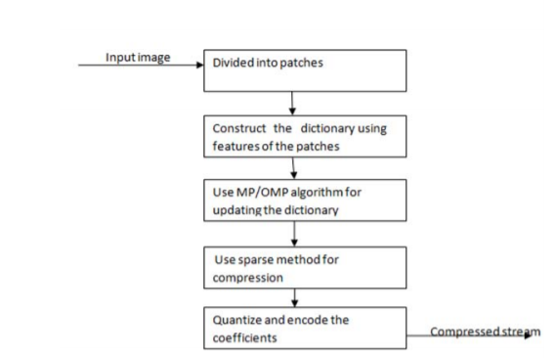

6.2 DATA FLOW DIAGRAM:

- The DFD is also called as bubble chart. It is a simple graphical formalism that can be used to represent a system in terms of input data to the system, various processing carried out on this data, and the output data is generated by this system.
- The data flow diagram (DFD) is one of the most important modeling tools. It is used to model the system components. These components are the system process, the data used by the process, an external entity that interacts with the system and the information flows in the system.
- DFD shows how the information moves through the system and how it is modified by a series of transformations. It is a graphical technique that depicts information flow and the transformations that are applied as data moves from input to output.
- DFD is also known as bubble chart. A DFD may be used to represent a system at any level of abstraction. DFD may be partitioned into levels that represent increasing information flow and functional detail.

Check

User
Unauthorized user

Upload Image

Compress Image using SVD

Comparison Graph

Close Application

End process

6.3 UML DIAGRAMS:
UML stands for Unified Modeling Language. UML is a standardized general-purpose modeling language in the field of object-oriented software engineering. The standard is managed, and was created by, the Object Management Group.
The goal is for UML to become a common language for creating models of object oriented computer software. In its current form UML is comprised of two major components: a Meta-model and a notation. In the future, some form of method or process may also be added to; or associated with, UML.
The Unified Modeling Language is a standard language for specifying, Visualization, Constructing and documenting the artifacts of software system, as well as for business modeling and other non-software systems.
The UML represents a collection of best engineering practices that have proven successful in the modeling of large and complex systems.
The UML is a very important part of developing objects oriented software and the software development process. The UML uses mostly graphical notations to express the design of software projects.

GOALS:
The Primary goals in the design of the UML are as follows:
- Provide users a ready-to-use, expressive visual modeling Language so that they can develop and exchange meaningful models.
- Provide extendibility and specialization mechanisms to extend the core concepts.
- Be independent of particular programming languages and development process.
- Provide a formal basis for understanding the modeling language.
- Encourage the growth of OO tools market.
- Integrate best practices.

USE CASE DIAGRAM:
A use case diagram in the Unified Modeling Language (UML) is a type of behavioral diagram defined by and created from a Use-case analysis. Its purpose is to present a graphical overview of the functionality provided by a system in terms of actors, their goals (represented as use cases), and any dependencies between those use cases. The main purpose of a use case diagram is to show what system functions are performed for which actor. Roles of the actors in the system can bedepicted.
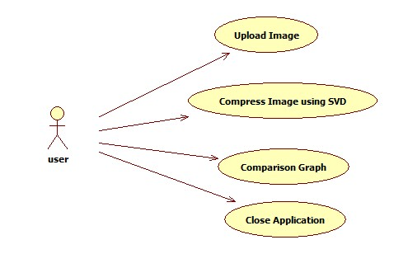
CLASS DIAGRAM:
In software engineering, a class diagram in the Unified Modeling Language (UML) is a type of static structure diagram that describes the structure of a system by showing the system's classes, their attributes, operations (or methods), and the relationships among the classes. It explains which class contains information.

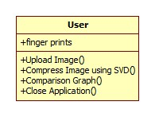
SEQUENCE DIAGRAM:
A sequence diagram in Unified Modeling Language (UML) is a kind of interaction diagram that shows how processes operate with one another and in what order. It is a construct of a Message Sequence Chart. Sequence diagrams are sometimes called event diagrams, event scenarios, and timing diagrams.

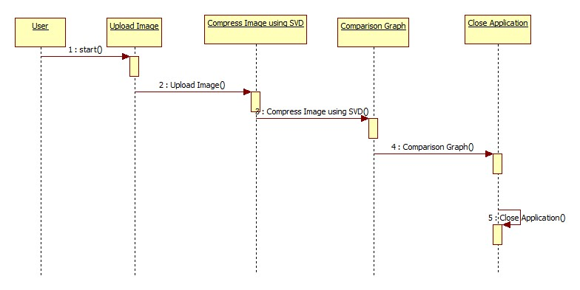
ACTIVITY DIAGRAM:
Activity diagrams are graphical representations of workflows of stepwise activities and actions with support for choice, iteration and concurrency. In the Unified Modeling Language, activity diagrams can be used to describe the business and operational step-by-step workflows of components in a system. An activity diagram shows the overall flow of control.
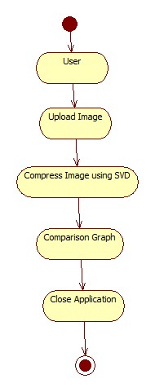

7. IMPLEMENTATION

7.1 MODULES:
- Upload Image
- Compress Image using SVD
- Comparison Graph
- Close Application

MODULES DESCRIPTION:

7.2 SAMPLE CODE

8. SYSTEM TESTING

The purpose of testing is to discover errors. Testing is the process of trying to discover every conceivable fault or weakness in a work product. It provides a way to check the functionality of components, sub assemblies, assemblies and/or a finished product It is the process of exercising software with the intent of ensuring that the Software system meets its requirements and user expectations and does not fail in an unacceptable manner. There are various types of test. Each test type addresses a specific testing requirement.

TYPES OF TESTS

Unit testing:
Unit testing involves the design of test cases that validate that the internal program logic is functioning properly, and that program inputs produce valid outputs. All decision branches and internal code flow should be validated. It is the testing of individual software units of the application .it is done after the completion of an individual unit before integration. This is a structural testing, that relies on knowledge of its construction and is invasive. Unit tests perform basic tests at component level and test a specific business process, application, and/or system configuration. Unit tests ensure that each unique path of a business process performs accurately to the documented specifications and contains clearly defined inputs and expected results.

Integration testing:
Integration tests are designed to test integrated software components to determine if they actually run as one program. Testing is event driven and is more concerned with the basic outcome of screens or fields. Integration tests demonstrate that although the components were individually satisfaction, as shown by successfully unit testing, the combination of components is correct and consistent. Integration testing is specifically aimed at exposing the problems that arise from the combination of components.

Functional test:
Functional tests provide systematic demonstrations that functions tested are available as specified by the business and technical requirements, system documentation, and user manuals.
Functional testing is centered on the following items:
Valid Input : identified classes of valid input must be accepted.
Invalid Input : identified classes of invalid input must be rejected.
Functions : identified functions must be exercised.
Output : identified classes of application outputs must be exercised.
Systems/Procedures : interfacing systems or procedures must be invoked.
Organization and preparation of functional tests is focused on requirements, key functions, or special test cases. In addition, systematic coverage pertaining to identify Business process flows; data fields, predefined processes, and successive processes must be considered for testing. Before functional testing is complete, additional tests are identified and the effective value of current tests is determined.

System Test:
System testing ensures that the entire integrated software system meets requirements. It tests a configuration to ensure known and predictable results. An example of system testing is the configuration oriented system integration test. System testing is based on process descriptions and flows, emphasizing pre-driven process links and integration points.

White Box Testing:
White Box Testing is a testing in which in which the software tester has knowledge of the inner workings, structure and language of the software, or at least its purpose. It is purpose. It is used to test areas that cannot be reached from a black box level.

Black Box Testing:
Black Box Testing is testing the software without any knowledge of the inner workings, structure or language of the module being tested. Black box tests, as most other kinds of tests, must be written from a definitive source document, such as specification or requirements document, such as specification or requirements document. It is a testing in which the software under test is treated, as a black box .you cannot “see” into it. The test provides inputs and responds to outputs without considering how the software works.
8.1 Unit Testing:
Unit testing is usually conducted as part of a combined code and unit test phase of the software lifecycle, although it is not uncommon for coding and unit testing to be conducted as two distinct phases.

Test strategy and approach:
Field testing will be performed manually and functional tests will be written in detail.

Test objectives:
- All field entries must work properly.
- Pages must be activated from the identified link.
- The entry screen, messages and responses must not be delayed.

Features to be tested
- Verify that the entries are of the correct format
- No duplicate entries should be allowed
- All links should take the user to the correct page.

8.2 Integration Testing
Software integration testing is the incremental integration testing of two or more integrated software components on a single platform to produce failures caused by interface defects.
The task of the integration test is to check that components or software applications, e.g. components in a software system or – one step up – software applications at the company level – interact without error.
Test Results: All the test cases mentioned above passed successfully. No defects encountered.

8.3 Acceptance Testing
User Acceptance Testing is a critical phase of any project and requires significant participation by the end user. It also ensures that the system meets the functional requirements.
Test Results: All the test cases mentioned above passed successfully. No defects encountered.

9. INPUT DESIGN AND OUTPUT DESIGN
9.1 INPUT DESIGN:
The input design is the link between the information system and the user. It comprises the developing specification and procedures for data preparation and those steps are necessary to put transaction data in to a usable form for processingcan be achieved by inspecting the computer to read data from a written or printed document or it can occur by having people keying the data directly into the system. The design of input focuses on controlling the amount of input required, controlling the errors, avoiding delay, avoiding extra steps and keeping the process simple. The input is designed in such a way so that it provides security and ease of use with retaining the privacy. Input Design considered the following things:
- What data should be given as input?
- How the data should be arranged or coded?
- The dialog to guide the operating personnel in providing input.
- Methods for preparing input validations and steps to follow when error occur.
OBJECTIVES:
1. Input Design is the process of converting a user-oriented description of the input into a computer-based system. This design is important to avoid errors in the data input process and show the correct direction to the management for getting correct information from the computerized system.
2.It is achieved by creating user-friendly screens for the data entry to handle large volume of data. The goal of designing input is to make data entry easier and to be free from errors. The data entry screen is designed in such a way that all the data manipulates can be performed. It also provides record viewing facilities.
3. When the data is entered it will check for its validity. Data can be entered with the help of screens. Appropriate messages are provided as when needed so that the user will not be in maize of instant. Thus the objective of input design is to create an input layout that is easy to follow
9.2 OUTPUT DESIGN:
A quality output is one, which meets the requirements of the end user and presents the information clearly. In any system results of processing are communicated to the users and to other system through outputs. In output design it is determined how the information is to be displaced for immediate need and also the hard copy output. It is the most important and direct source information to the user. Efficient and intelligent output design improves the system’s relationship to help user decision-making.
1. Designing computer output should proceed in an organized, well thought out manner; the right output must be developed while ensuring that each output element is designed so that people will find the system can use easily and effectively. When analysis design computer output, they should Identify the specific output that is needed to meet the requirements.
2. Select methods for presenting information.
3. Create document, report, or other formats that contain information produced by the system.
The output form of an information system should accomplish one or more of the following objectives.
- Convey information about past activities, current status or projections of the
- Future.
- Signal important events, opportunities, problems, or warnings.
- Trigger an action.
- Confirm an action.
10. SCREENSHOTS
To run project double click on ‘run.bat’ file to get below screen
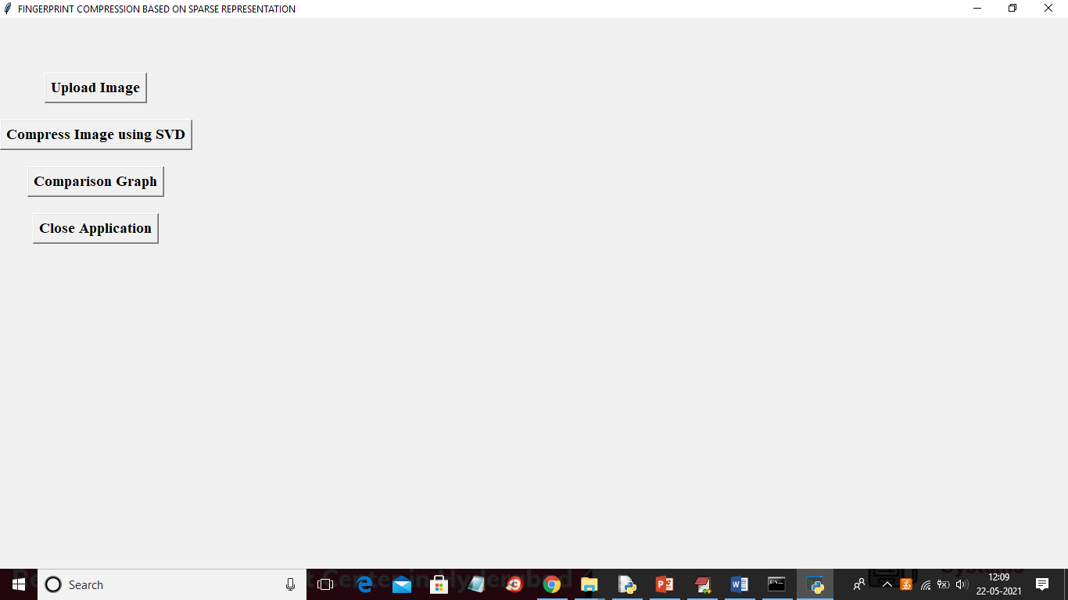
In above screen click on ‘Upload Image’ button to upload image
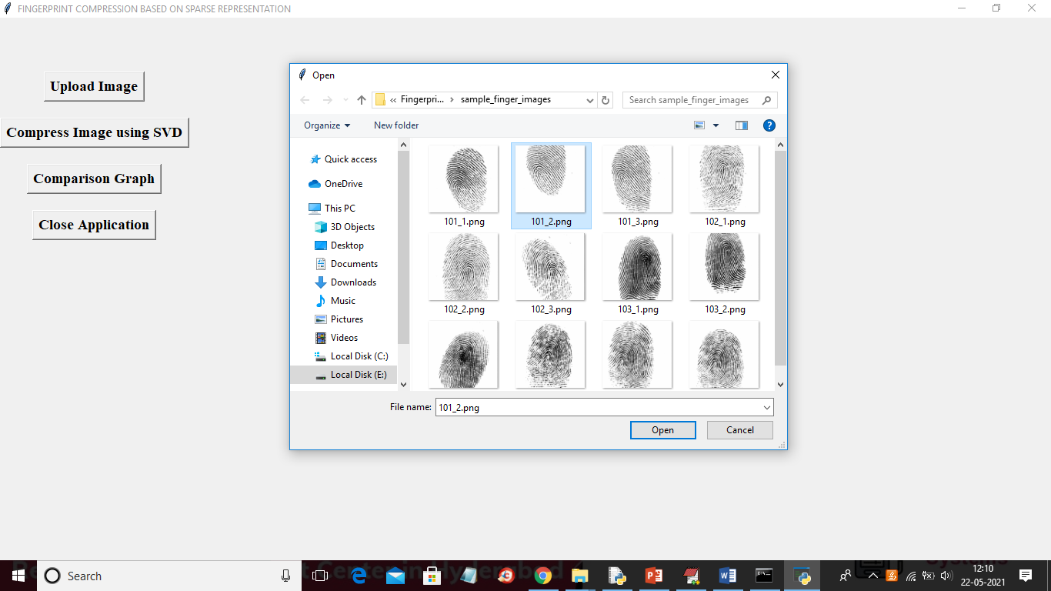
In above screen selecting and uploading ‘101_2.png’ file and then click on ‘Open’ button to load image and to get below screen
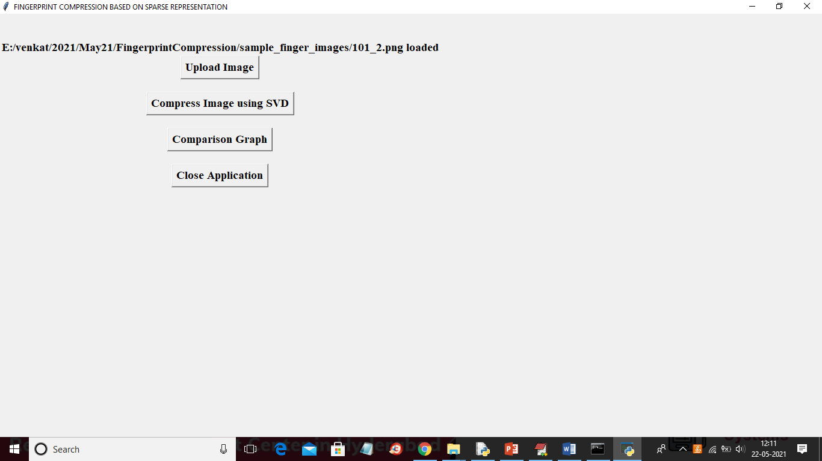
In above screen image loaded and now click on ‘Compress Image using SVD’ button to compress image and then will get below screen
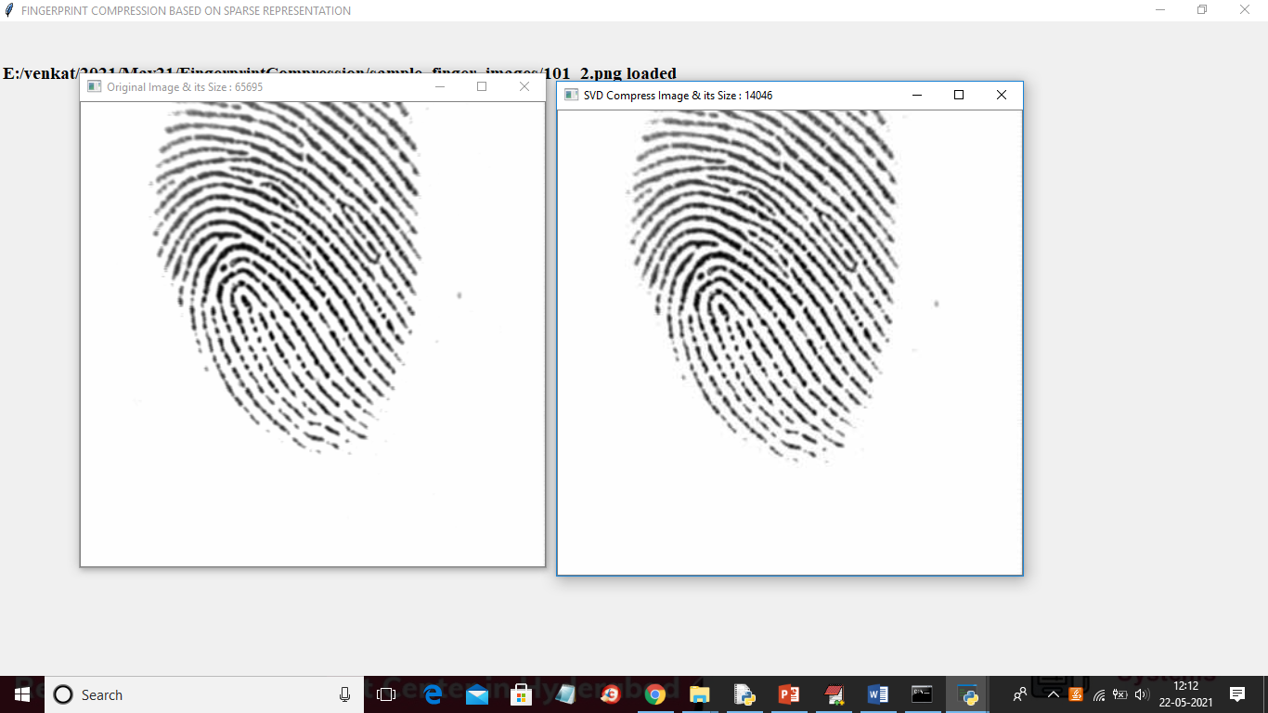
In above screen first image is the original image and in the title bar of image you can see their size in bytes where original image having size as 65695 bytes and SVD compress image size is 14046 bytes and the same size you can see in below image directory
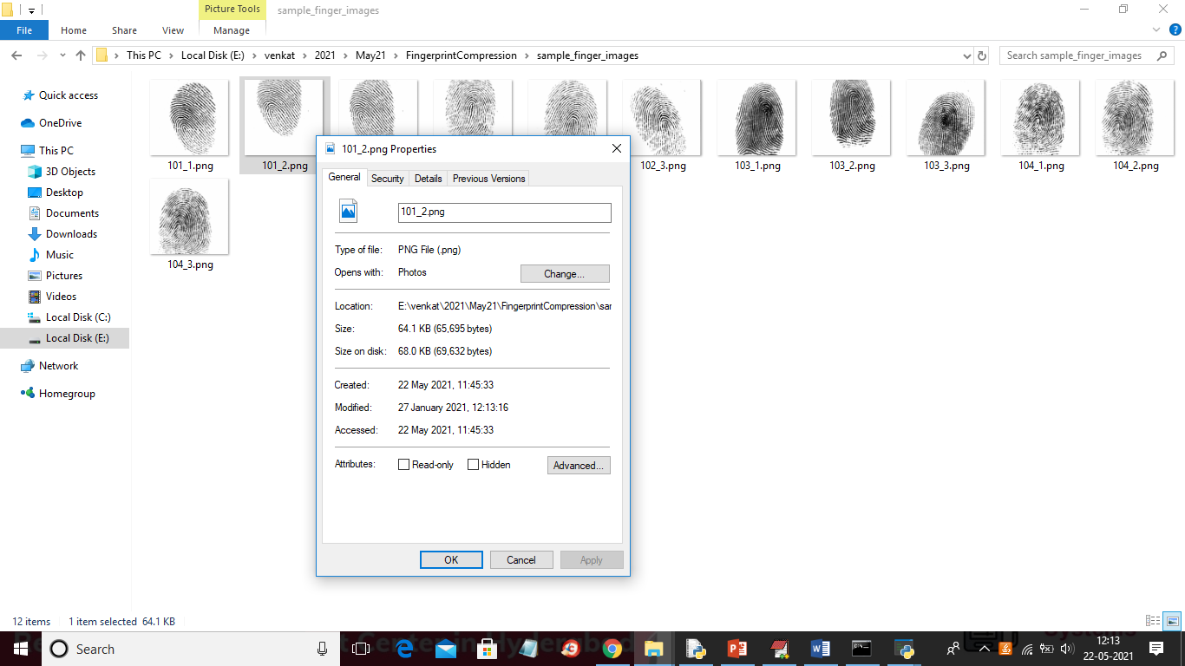
In above screen for 101_2.png the image size is 64.1 KB and see the same image size in compress folder after compression
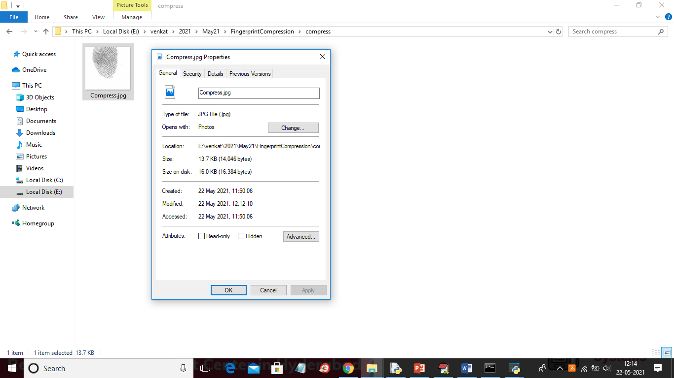
In above screen after compression the same image size is reduced to 13.7 KB. Similarly you can upload other images and test and now click on ‘Comparison Graph’ button to get below graph
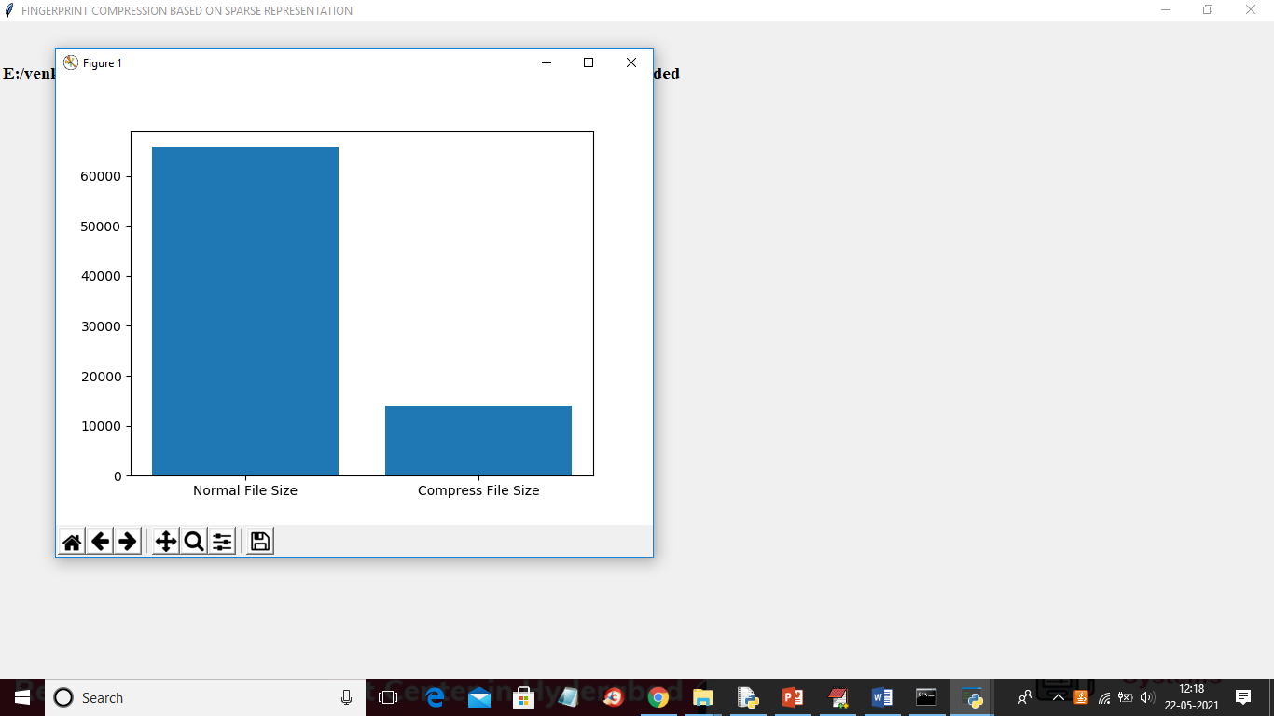
In above graph x-axis represents technique name and y-axis represents image size and in above screen we can see after compression images size is reduced

11. FUTURE ENHANCEMENT
There are many intriguing questions that future work should consider. First, the features and the methods for constructing dictionaries should be thought over. Secondly, the training samples should include fingerprints with different quality (“good”, “bad”, “ugly”). Thirdly, the optimization algorithms for solving the sparse representation need to be investigated. Fourthly, optimize the code to reduce complexity of our proposed method. Finally, other applications based on sparse representation for fingerprint images should be explored.

12. CONCLUSION

A new compression algorithm adapted to fingerprint images is introduced. Despite the simplicity of our proposed algorithms, they compare favorably with existing more sophisticated algorithms, especially at high compression ratios. Due to the block-by-block processing mechanism, however, the algorithm has higher complexities. The experiments show that the block effect of our algorithm is less serious than that of JPEG. We consider the effect of three different dictionaries on fingerprint compression. The experiments reflect that the dictionary obtained by the K-SVD algorithm works best. Moreover, the larger the number of the training set is, the better the compression result is. One of the main difficulties in developing compression algorithms for fingerprints resides in the need for preserving the minutiae which are used in the identification. The experiments show that our algorithm can hold most of the minutiae robustly during the compression and reconstruction.

13. BIBLIOGRAPHY

[1] D. Maltoni, D. Miao, A. K. Jain, and S. Prabhakar, Handbook of Fingerprint Recognition, 2nd ed. London, U.K.: Springer-Verlag, 2009.
[2] N. Ahmed, T. Natarajan, and K. R. Rao, “Discrete cosine transform,” IEEE Trans. Comput., vol. C-23, no. 1, pp. 90–93, Jan. 1974.
[3] C. S. Burrus, R. A. Gopinath, and H. Guo, Introduction to Wavelets and Wavelet Transforms: A Primer. Upper Saddle River, NJ, USA: PrenticeHall, 1998.
[4] W. Pennebaker and J. Mitchell, JPEG—Still Image Compression Standard. New York, NY, USA: Van Nostrand Reinhold, 1993.
[5] M. W. Marcellin, M. J. Gormish, A. Bilgin, and M. P. Boliek, “An overview of JPEG-2000,” in Proc. IEEE Data Compress. Conf., Mar. 2000, pp. 523–541.
[6] A. Skodras, C. Christopoulos, and T. Ebrahimi, “The JPEG 2000 still image compression standard,” IEEE Signal Process. Mag., vol. 11, no. 5, pp. 36–58, Sep. 2001.
[7] T. Hopper, C. Brislawn, and J. Bradley, “WSQ gray-scale fingerprint image compression specification,” Federal Bureau of Investigation, Criminal Justice Information Services, Washington, DC, USA, Tech. Rep. IAFIS-IC-0110-V2, Feb. 1993.
[8] C. M. Brislawn, J. N. Bradley, R. J. Onyshczak, and T. Hopper, “FBI compression standard for digitized fingerprint images,” Proc. SPIE, vol. 2847, pp. 344–355, Aug. 1996.
[9] A. Said and W. A. Pearlman, “A new, fast, and efficient image codec based on set partitioning in hierarchical trees,” IEEE Trans. Circuits Syst. Video Technol., vol. 6, no. 3, pp. 243–250, Jun. 1996.
[10] R. Sudhakar, R. Karthiga, and S. Jayaraman, “Fingerprint compression using contourlet transform with modified SPIHT algorithm,” IJECE Iranian J. Electr. Comput. Eng., vol. 5, no. 1, pp. 3–10, 2005. [11] S. G. Mallat and Z. Zhang, “Matching pursuits with timefrequency dictionaries,” IEEE Trans. Signal Process., vol. 41, no. 12, pp. 3397–3415, Dec. 1993.
[12] S. S. Chen, D. Donoho, and M. Saunders, “Atomic decomposition by basis pursuit,” SIAM Rev., vol. 43, no. 1, pp. 129–159, 2001.
[13] J. Wright, A. Y. Yang, A. Ganesh, S. S. Sastry, and Y. Ma, “Robust face recognition via sparse representation,” IEEE Trans. Pattern Anal. Mach. Intell., vol. 31, no. 2, pp. 210–227, Feb. 2009.
[14] M. Elad and M. Aharon, “Image denoising via sparse and redundant representation over learned dictionaries,” IEEE Trans. Image Process., vol. 15, no. 12, pp. 3736–3745, Dec. 2006.
[15] S. Agarwal and D. Roth, “Learning a sparse representation for object detection,” in Proc. Eur. Conf. Comput. Vis., 2002, pp. 113–127.
[16] J. Yang, J. Wright, T. Huang, and Y. Ma, “Image super-resolution as sparse representation of raw image patches,” in Proc. IEEE Conf. Comput. Vis. Pattern Recognit., Jun. 2008, pp. 1–8.
[17] K. Skretting and K. Engan, “Image compression using learned dictionaries by RLS-DLA and compared with K-SVD,” in Proc. IEEE ICASSP, May 2011, pp. 1517–1520.
[18] O. Bryt and M. Elad, “Compression of facial images using the K-SVD algorithm,” J. Vis. Commun. Image Represent., vol. 19, no. 4, pp. 270–282, 2008.
[19] Y. Y. Zhou, T. D. Guo, and M. Wu, “Fingerprint image compression algorithm based on matrix optimization,” in Proc. 6th Int. Conf. Digital Content, Multimedia Technol. Appl., 2010, pp. 14–19.
[20] A. J. Ferreira and M. A. T. Figueiredo, “Class-adapted image compression using independent component analysis,” in Proc. Int. Conf. Image Process., vol. 1. 2003, pp. 625–628
. [21] A. J. Ferreira and M. A. T. Figueiredo, “On the use of independent component analysis for image compression,” Signal Process., Image Commun., vol. 21, no. 5, pp. 378–389, 2006.
[22] P. Paatero and U. Tapper, “Positive matrix factorization: A nonnegative factor model with optimal utilization of error estimates of data values,” Environmetrics, vol. 5, no. 1, pp. 111–126, 1994.
[23] D. D. Leeand and H. S. Seung, “Learning the parts of objects by nonnegative matrix factorization,” Nature, vol. 401, pp. 799–791, Oct. 1999.
[24] E. Amaldi and V. Kann, “On the approximability of minimizing nonzero variables or unsatisfied relations in linear systems,” Theoretical Comput. Sci., vol. 209, nos. 1–2, pp. 237–260, 1998.
[25] S. Mallat and Z. Zhang, “Matching pursuits with time-frequency dictionaries,” IEEE Trans. Signal Process., vol. 41, no. 12, pp. 3397–3415, Dec. 1993.
[26] Y. C. Pati, R. Rezaiifar, and P. S. Krishnaprasad, “Orthogonal matching pursuit: Recursive function approximation with applications to wavelet decomposition,” in Proc. Conf. Rec. 27th Asilomar Conf. Signals, Syst. Comput., Nov. 1993, pp. 40–44.
[27] E. Candes, J. Romberg, and T. Tao, “Stable signal recovery from incomplete and inaccurate measurements,” Commun. Pure Appl. Math., vol. 59, no. 8, pp. 1207–1223, 2006.
[28] E. Candes, J. Romberg, and T. Tao, “Near-optimal signal recovery from random projections: Universal encoding strategies?” IEEE Trans. Inf. Theory, vol. 52, no. 12, pp. 5406–5425, Dec. 2006.
[29] D. Donoho, “For most large underdetermined systems of linear equations the minimal 1-norm solution is also the sparsest solution,” Commun. Pure Appl. Math., vol. 59, no. 6, pp. 797–829, 2006.
[30] E. Candes and Y. Plan, “Near-ideal model selection by 1 minimization,” Ann. Statist., vol. 37, no. 5A, pp. 2145–2177, 2009.
[31] I. F. Gorodnitsky and B. D. Rao, “Sparse signal reconstruction from limited data using FOCUSS: A re-weighted norm minimization algorithm,” IEEE Trans. Signal Process., vol. 45, no. 3, pp. 600–616, Mar. 1997.
[32] A. Beck and M. Teboulle, “A fast iterative shrinkage-thresholding algorithm for linear inverse problems,” SIAM J. Imag. Sci., vol. 2, no. 1, pp. 183–202, 2009.
[33] M. Aharon, M. Elad, and A. M. Bruckstein, “On the uniqueness of overcomplete dictionaries, and a practical way to retrieve them,” J. Linear Algebra Appl., vol. 416, no. 1, pp. 48–67, 2006.
[34] M. Aharon, M. Elad, and A. M. Bruckstein, “The K-SVD: An algorithm for designing of overcomplete dictionaries for sparse representation,” IEEE Trans. Signal Process., vol. 54, pp. 4311–4322, 2006.
[35] K. Sayood, Introduction to Data Compression, 3rd ed. San Mateo, CA, USA: Morgan Kaufman, 2005, pp. 81–115. [36] S. Lloyd, “Least squares quantization in PCM,” IEEE Trans. Inf. Theory, vol. 28, no. 2, pp. 129–137, Mar. 1982.
[37] (2013, Jun.). Fingerprint Images [Online]. Available: http://pan.baidu.com/share/link?shareid= 3872475108&uk=2301599420
[38] (2012, Dec.). SetupWSQ [Online]. Available: http://www.download3k.com/Install-WSQ-viewer.html
[39] S. Prabhakar, “Fingerprint classification and matching using a filterbank,” Ph.D. dissertation, Dept. Comput. Sci., Eng., Michigan State Univ., East Lansing, MI, USA, 2001.

